Absolute grass biomass
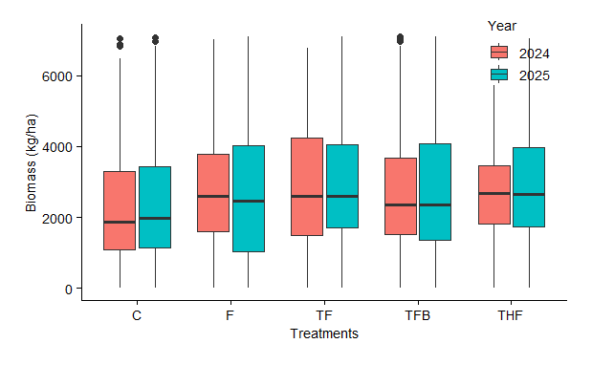- No significant difference in grass biomass between 2024 and 2025 (p = 0.385).
- Strong evidence that treatment type affects grass biomass (p < 0.001).
- No significant interaction between year and treatment — this means the effect of treatment is fairly consistent across both years.
Interpretation
- Among the treated plots, no combination of thinning, fire, herbicide, or browsing was significantly better or worse in terms of grass biomass.

